**Introduction:**

In this project, we are planning to develop an online package tracking system where anyone would be able to track their packages in our website irrespective of the carrier. Whenever you search for a package, we will not just redirect your request to the carrier service website instead we will maintain the database on the whole from our end which enables the carrier service to least worry about their database. In short, the carriers will outsource their IT part to us where we will be able to offer the service at a very less cost with the advantage of resource sharing since we do it for more than one carriers.

Basic models being involved in the project are:

* **Shipment Tracking by the Customer:**

Below is the very basic layout of the front page where the customer will be allowed to enter the shipment type and package identification number for which he requires tracking information.

Track the Package

xxxxxxxxxxxxxxx

USPS

Shipment:

Tracking Number:

Below layout will display the entire details of the package

Tracking Number: xxxxxxxxxxxxxxxx

Expected Delivery Day: xxxxxxxxxxxxx

Package Description: xxxxxxxxxxxxxxxx

Shipment Address: xxxxxxxxxxxxxxxxxx

**Tracking Information:**

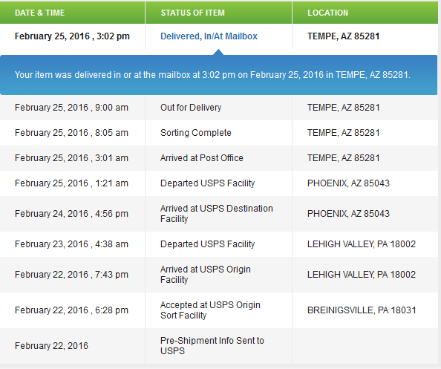



* **Updating package status**

We will have a separate log in page for the employees who will provide their username and password in order to view the packages for which he is responsible in updating the status.

EMPLOYEES SIGN IN:

Select Office:

xxxxxxxxxxxxx

FedEx

Password:

User ID:

xxxxxxxxxxxxxxxxxxx

Sign In

Here he will be able to view the list of orders and he will be able to click the hyperlink and update the details for the orders.

EMPLOYEE ORDERS:

Employee Name: xxxxxxxx

|  |
| --- |
| 1. xxxxxxxx |
| 2. xxxxxxxx |
| 3. xxxxxxxx |
| 4. xxxxxxxx |
| 5. xxxxxxxx |
| 6. xxxxxxxx |
| 7. xxxxxxxx |

* **Shipment History**

This is the page which will get displayed when he is clicking on any of the hyperlinks. He will be able to view the details of the orders, update the status and comments for each of the orders.

UPDATE

SHIPMENT HISTORY:

Shipment ID: xxxxxxxxxxx

Product Name: xxxxxxxxxxxxx

Expected Delivery Date: xxxxxxxxxxx

Shipment History:

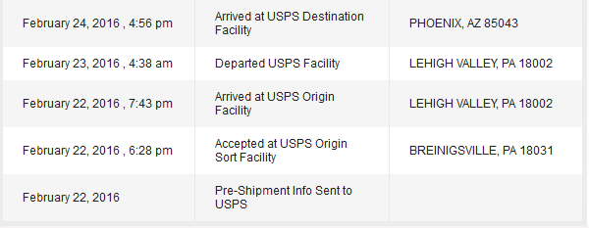

**Next Status:**

State:

Comments: xxxxxxxxxxxxxxxxxxxxx

xxxxxxxxxxxxxxxx

* **Additional Add-ons:**

Along with the above mentioned basic models we also have plans to implement the below add-ons if the time permits.

1. Employee registration: Here we will have a page where the employee will provide his credentials and validate in order to create a username and password for him to access to this site.
2. Shipment pickup: There will be a separate page for the shipment pickup facility where the customer will be able to raise request for shipment pickup with a specific courier service of their own choice.
3. Complaint registration: Separate page for complaint registration where customer will be able to lodge complaints with any of the carriers with package number as reference. In this case, username and password will be provided to a supervisor who will be logging in to check the complaints and assign it to the concerned employee.
4. Also, we will have an automated notification system which will intimate the employee if there is any order for which the expected delivery date is passed but status not updated.